BestFriend App

Documentation

1. Introduction

I chose, for my final OOP class project, to develop an android studio application which returns the user the Facebook friend who liked the most posts on his timeline. The app can be implemented as a part of a full scale Facebook statistics application, but for now it shall be used only for personal fun.

1. Use cases

The app is quite simple to use, following the steps below:

* Starting the app

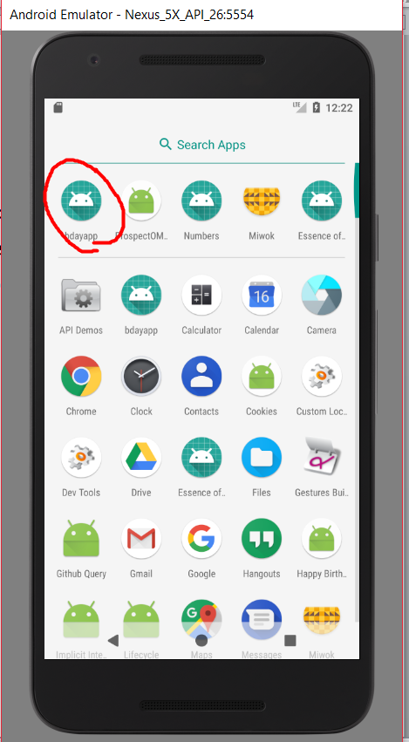

* Logging in with your facebook account

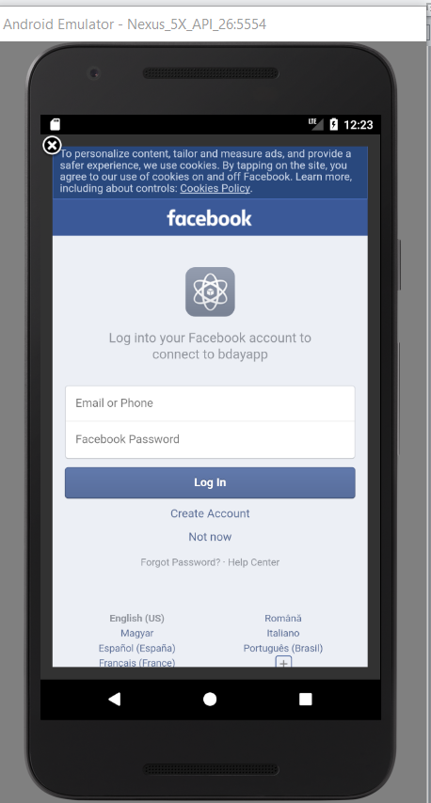

* Introducing the security code, in case of two-step authentication

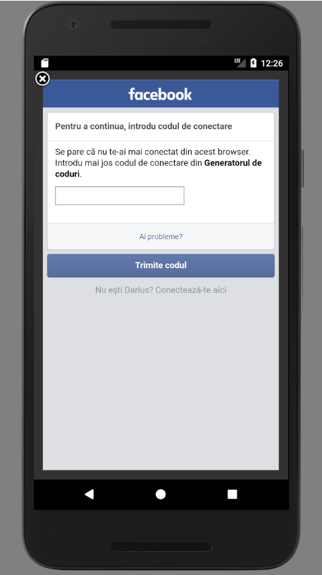

* Click the “Find the best facebook friend” button

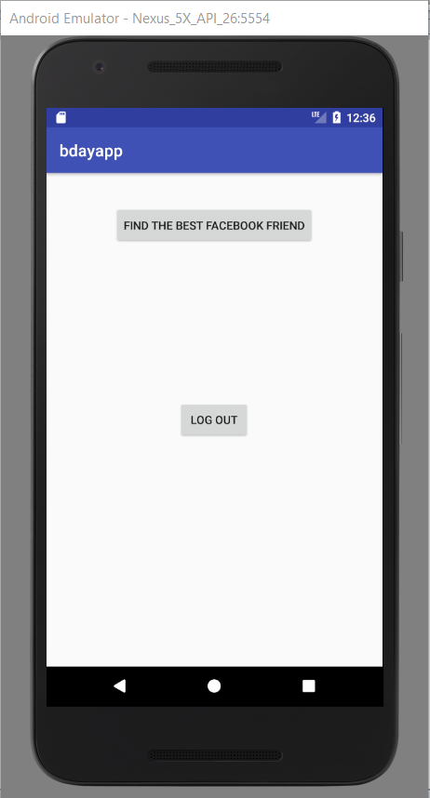

* The full name of the friend who reacted to the most of the user’s posts will be displayed

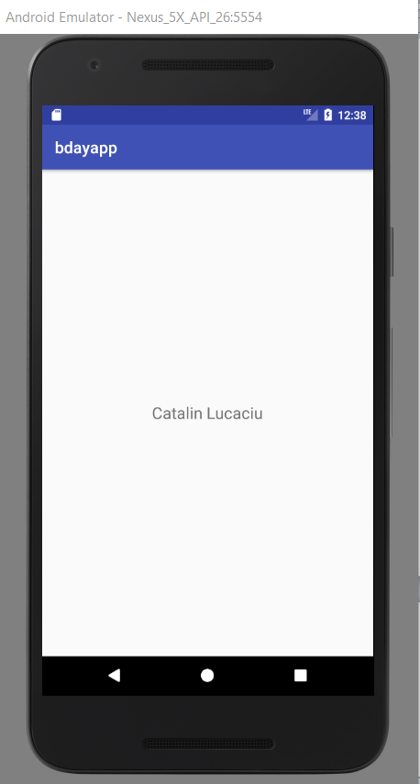

1. App design and implementation details

* The main screen

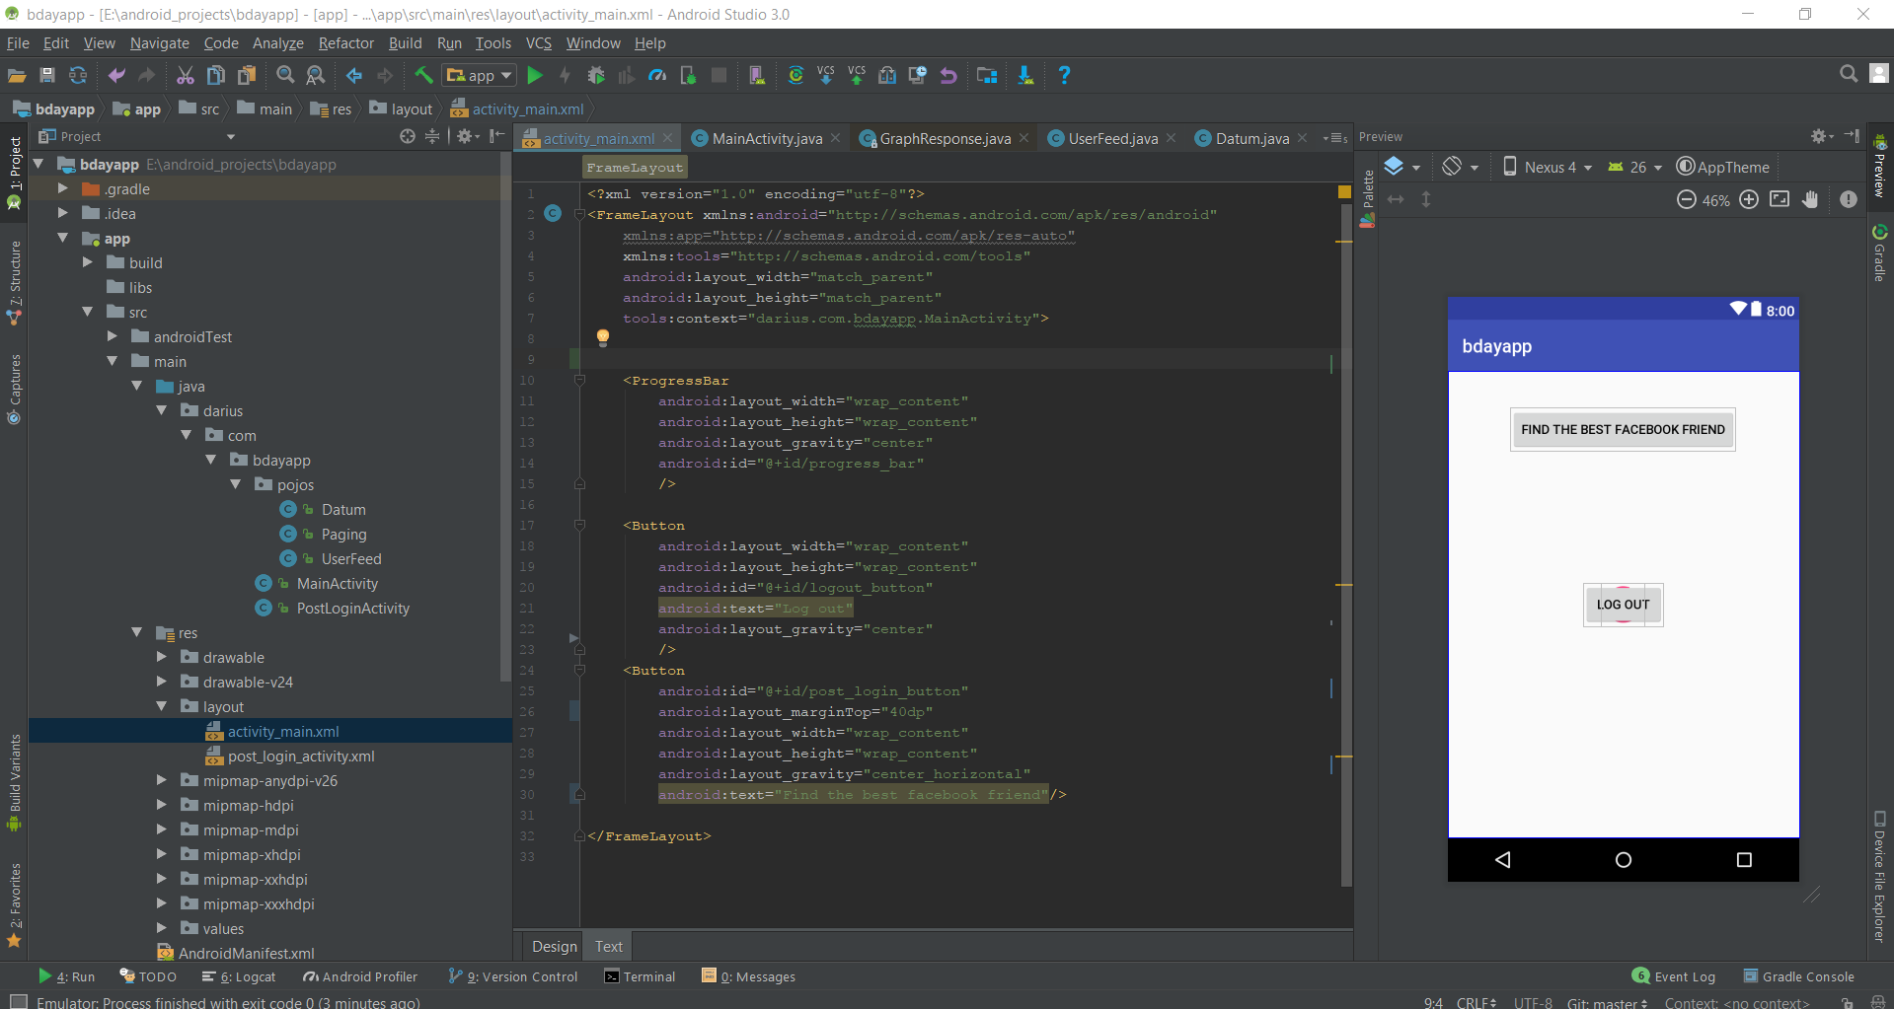

The main screen comes with two buttons, one for logging out in the case the user is already logged in and one for running the algorithm that returns the friend who gave the most likes.

The main screen comes with a main activity, which checks if the user is logged in or not. In case he is not logged in a facebook login window will pop-up automatically and the user must introduce his username and password. At the login procedure the following user permissions are added: “user_firends” and “user_posts”. By accepting these permissions the app gains access to the facebook account’s timeline. After the user gets logged in, or if he is already, the “log out” and “find the best facebook friend” buttons appear on the main screen ad they can be used. If the user logs out the app will be closed (will be solved in future versions) and if the other button is pressed a new intent is created to the “PostLoginActivity”.

* The secondary screen

The secondary screen contains a simple text view which will receive the result of the algorithm for finding the facebook friend who gave the most likes. The text view is initially empty. While the algorithm is being performed there is a “loading” bar which indicates that the system is working.

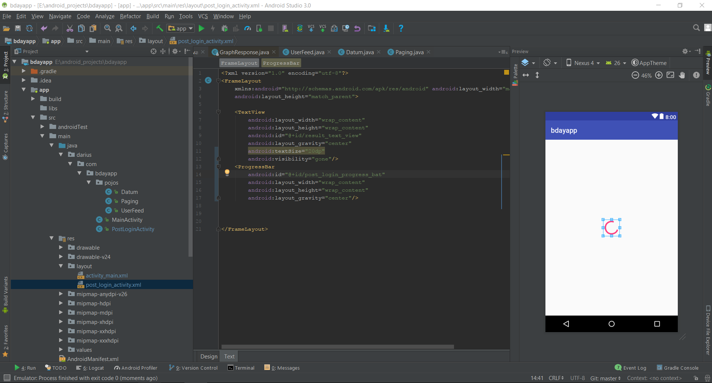

The secondary screen comes with a PostLoginActivity where successive Facebook Graph API requests are being done. First of all, the app gets the user’s feed. The result is being obtained as JSON and it is manually parsed, extracting each post, and getting its id. The id is being used in order to make another request which returns the people who liked that specific post by their id and name. A hash map is being created, the key being formed by taking the user id. If the key is nonexistent it is added to the map, else the number of user likes is incremented and the maximum number of likes together with the user’s id with the maximum number of likes is being stored. A final request is made and it gets the Facebook name of user id which was stored. The name is displayed on the layout’s text view.

1. Future Development

The app has a lot of weaknesses to be improved. First, the UI must be updated in order to be more user-friendly. A Facebook Login/Logout original button can be implemented instead of the hardcoded one. The result should also contain the profile picture of the Facebook friend and a link to its profile. The code can be divided into separate classes, making it more accessible for other developers. You know, time crisis sometimes comes together with some good old fashion brute-force coding, but at least the app works fine in spite of the major flaws in the development process.